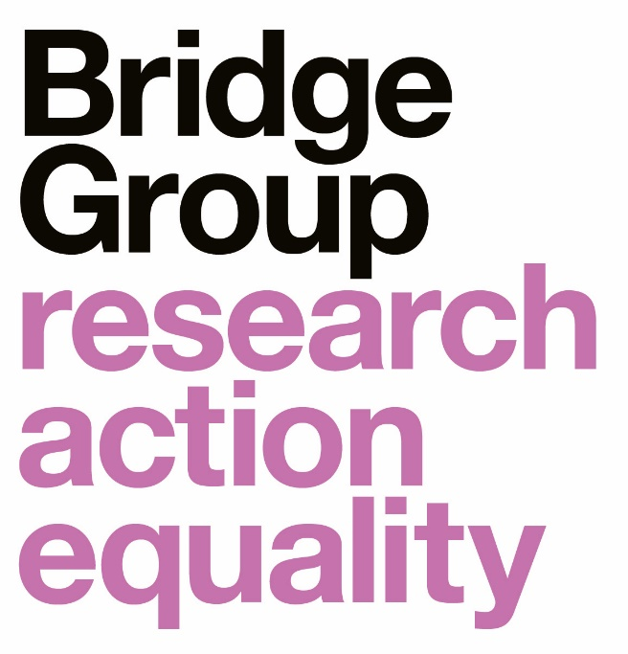

Report for the Sutton Trust and the Fulbright Commission

Sutton Trust US Programme: 2012-2021

Contents

Foreword from the Sutton Trust and the Fulbright Commission 1
Executive summary 3

Foreword from the Sutton Trust and the Fulbright Commission

It was over ten years ago that the Trust first started to consider a US programme, to build on its successful summer schools to widen access to leading UK universities. There were more and more young people considering the US for their studies, attracted by the great quality on offer and the benefits of a liberal arts education; but far too few of those youngsters were from low-income backgrounds and state schools. It was then that the Trust engaged with the US-UK Fulbright Commission, drawing on their unparalleled expertise of transatlantic higher education exchange, and the partnership between the two organisations was formed, which led to the establishment of the Sutton Trust US Programme.

The Sutton Trust and US-UK Fulbright Commission are proud of the impact that the Programme has had since that inception in 2012.

Through partnership, we have supported over 1300 students, and have enabled 514 individuals to access leading universities in the US, and many others to access leading universities here in the UK. This report allows us to reflect on those achievements and to better understand the impact that the programme has had on individual students.

We are delighted that so many of our students have reported the programme as life-changing and that it gave opportunities many students otherwise would not have had. These advantages include tangible outcomes – such as access to a liberal arts education at a US university for some, generous scholarships and financial aid that make opportunities possible – but also accompanying benefits such as participants’ increased confidence and ambitions, a strong sense of community and network of peers to inspire them, a broader, international outlook, and clarity and confidence in discussing and addressing issues of socio-economic disadvantage and other inequalities. We are pleased to see that this positive impact is felt by both students who attend US universities and those that decide to stay in the UK. We are beginning to see the longer-term outcomes of students on the programme through their choices post-graduation and employment data. We look forward to continuing to analyse these trends as more students graduate, so that we can understand how the programme ultimately impacts the social mobility of our students.

Over the last 10 years, the programme has been refined and adapted as we have applied learnings through delivery and we are proud that these changes have been positively reported by the later cohorts in the programme.

We also welcome findings on ways we can continue to improve the provision, including through mental health and transition support, extending networks and providing more guidance for those choosing to stay in the UK or who are unsuccessful in their US applications. We do not underestimate the challenge of moving abroad to study and of facing disappointment in applications and would like to thank all students for sharing their stories and experiences with us. Many of these programmatic changes are already underway with the launch of our Sutton Trust Online platform, our inclusion programming and the growth of our alumni offer. We will endeavour to ensure these areas of work meet the needs of future students.

The Sutton Trust and US-UK Fulbright Commission would like to extend our thanks to all students, universities, colleges and partners who contributed to this research and to the Bridge Group for undertaking the analysis.

Executive summary

- This research spans the first nine cohorts of participants in the Sutton Trust US Programme. Through surveys and interviews, we seek to:
- Recognise the broader positive impact of the Sutton Trust US Programme, beyond progression to highly selective US colleges
- Assess programme participants' experience of studying in the US
- Investigate what the programme could do, especially in Part 2, to prepare students better for studying in the US
- Assess the extent to which those participants who did not study in the US felt they had benefitted from the programme
- Assess the merits of a digitally delivered programme (Cohort 9 only).

- On average, 55% of participants in the Sutton Trust US Programme applied to US colleges. The programme alumni enrolling in a US college comprised over two-thirds (67%) of those applying and 37% of all programme alumni. This is a substantial proportion, given the highly selective nature of the destination colleges. While applications are relatively stable across cohorts (except Cohort 9), the proportions enrolling vary significantly.

- Survey respondents across all cohorts reported a highly positive impact. They were most likely to say that the programme impacted their broader outlook and ambitions and their understanding of US culture, politics and society. The outcomes on respondents from all three cohort groups were broadly similar. However, disaggregating by study destination suggests that the impact was generally greatest for those who studied in the US and least for those who completed Part 2, but did not go on to study in the US.

- Programme participants who decided not to apply to US colleges cited a preference for the UK higher education system as a key reason. This remained a strong factor for all three sets of cohorts. For those who attended Part 2 of the Sutton Trust US Programme but did not undertake their degrees in the US, the most cited reason was not being accepted to a US college.

- In the interviews, it emerged that participants had an overwhelmingly positive impression of the Sutton Trust US Programme. Both sets of alumni – participants who went on to study in the US and those that studied in the UK – described the programme as a pivotal life-changing experience.
- Interviewees reported that participation in the programme had a broad positive impact on personal development, international outlook and skill development – regardless of HEI destination. Moreover, the programme provided participants with a clear understanding of issues of socio-economic equality while building an inspiring community of like-minded individuals. Participants who went on to study in the UK as well as those who studied in the US all reported this positive impact.

- When those who had studied in the US were asked about the challenges of that experience, respondents from Cohorts 1-4 and 5-8 were most likely to cite managing their academic life and fitting in on campus in terms of their family background and income. These factors were challenging in second and subsequent years, as well as in the first year.

- Interviewees reported life at US colleges as being tough but rewarding, with many interviewees appreciating the freedoms of a liberal arts education. However, participants reported having to (and struggling to) navigate issues of racism and socio-economic inequality; and serious mental health problems.

- Over half the survey respondents from both cohort groups would have liked more support for certain issues, with more respondents from Cohorts 1-4 reporting this. Our findings suggest that Cohorts 5-8 benefitted from increased support before starting college in the US. However, the two cohort groups felt a broadly similar need for more support after starting study.

- Interviewees suggested developing further support, including the following:
- building and sustaining the alumni network
- setting appropriate and more realistic expectations at the beginning of Part 1 and Part 2, and before starting study in the US
- supporting participants after they have graduated from the programme, tailoring this to those who completed Part 1 and Part 2, and by final study destination, with additional transition support for those who progress to US colleges.

- A smaller proportion of Cohort 9 applied for a US college (35% of Cohort 9 cf an average of 61% for Cohorts 5-8). Time constraints was the most commonly cited reason and it is possible that the pressures of disrupted schooling and assessed exam grades during Covid-19 restrictions contributed to this. However, Cohort 9 reported a broader impact of the programme generally comparable with earlier cohort groups, despite digital delivery.

